**Assignment – 8**

Name: Siddharth Goyal

Enroll: 9918103232

Batch: F8

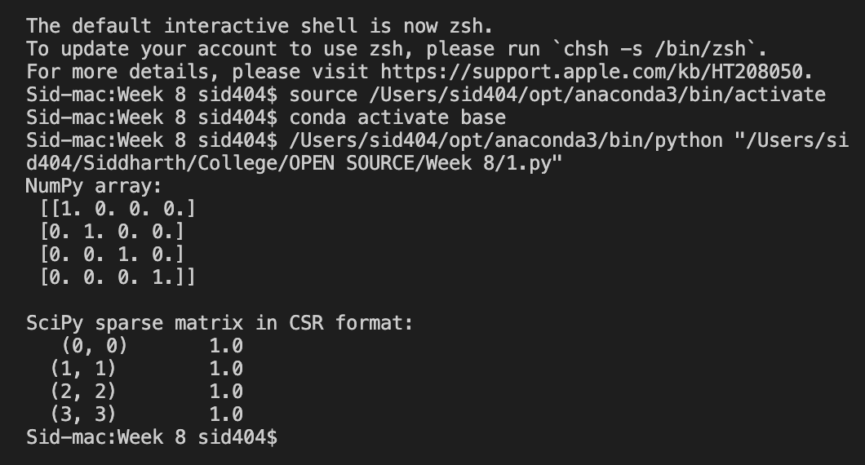

|  |
| --- |
| import numpy as np  from scipy import sparse  eye = np.eye(4)  print("NumPy array:\n", eye)  sparse_matrix = sparse.csr_matrix(eye)  print("\nSciPy sparse CSR matrix:\n", sparse_matrix) |

2)

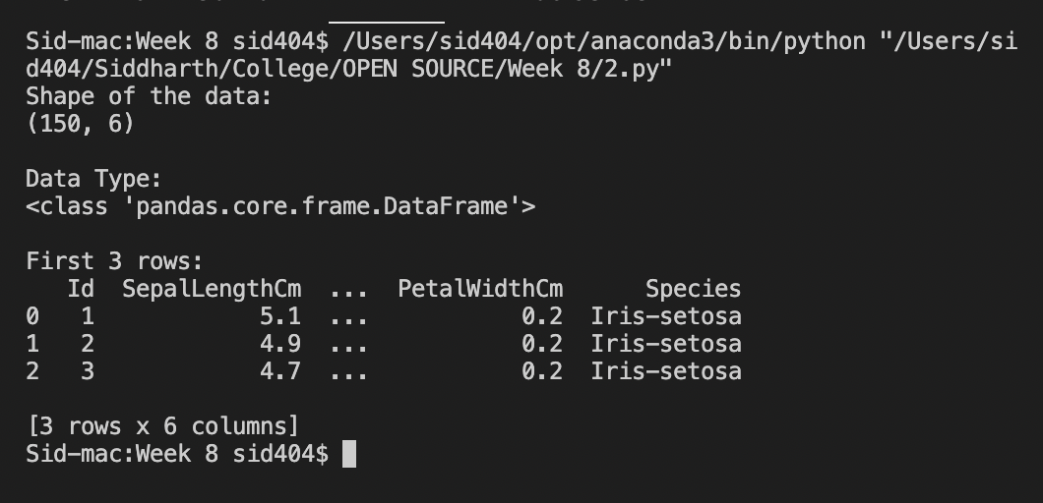

|  |
| --- |
| import pandas as pd  data = pd.read_csv("iris.csv")  print("Shape of the data:")  print(data.shape)  print("\nData Type:")  print(type(data))  print("\nFirst 3 rows:")  print(data.head(3)) |

3)

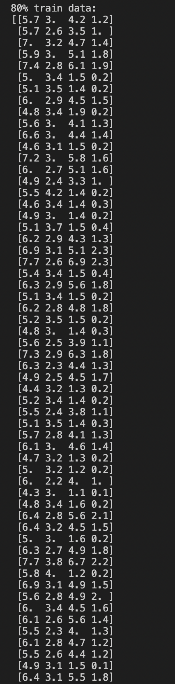

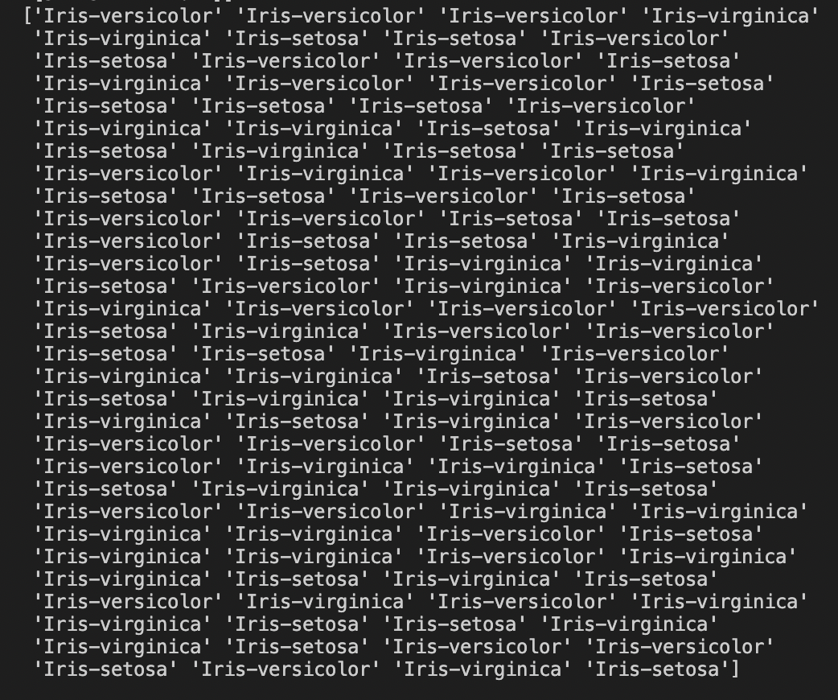

|  |
| --- |
| import pandas as pd  from sklearn.model_selection import train_test_split  iris = pd.read_csv("iris.csv")  #Drop id column  iris = iris.drop(columns='(150, 4, setosa, versicolor, virginica)',axis=1)  X = iris.iloc[:, :-1].values  y = iris.iloc[:, 4].values  #Split arrays or matrices into random train and test subsets  X_train, X_test, y_train, y_test = train_test_split(X, y, test_size=0.20)  print("\n70% train data:")  print(X_train)  print(y_train)  print("\n30% test data:")  print(X_test)  print(y_test) |

4)

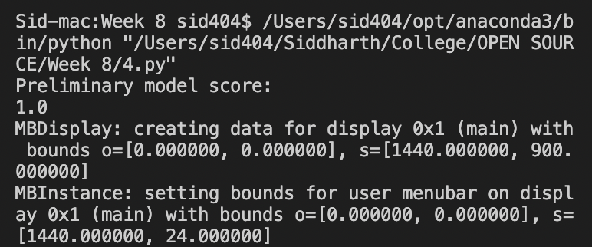

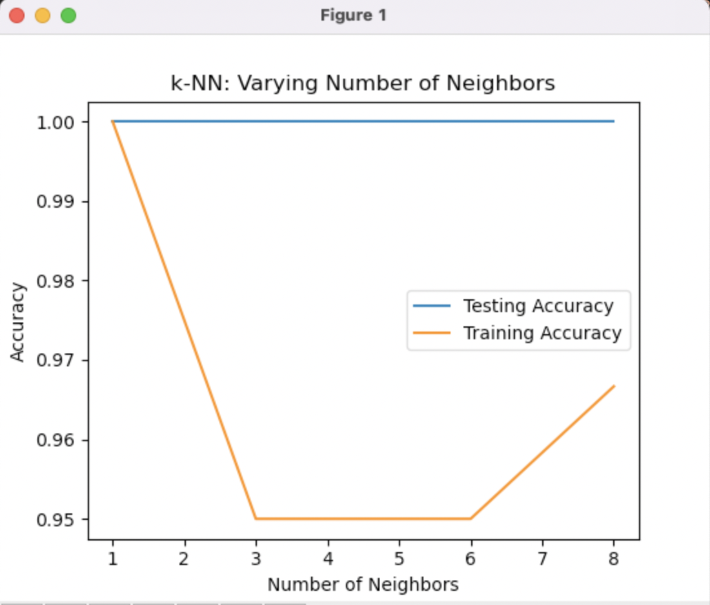

|  |
| --- |
| import pandas as pd  import matplotlib.pyplot as plt  import numpy as np  from sklearn.neighbors import KNeighborsClassifier  from sklearn.model_selection import train_test_split  iris = pd.read_csv("iris.csv")  iris = iris.drop('Id',axis=1)  X = iris.iloc[:, :-1].values  y = iris.iloc[:, 4].values  #Split arrays or matrices into train and test subsets  X_train, X_test, y_train, y_test = train_test_split(X, y, test_size=0.20)  knn = KNeighborsClassifier(n_neighbors=7)  knn = KNeighborsClassifier(n_neighbors=6)  knn.fit(X_train,y_train)  print("Preliminary model score:")  print(knn.score(X_test,y_test))  no_neighbors = np.arange(1, 9)  train_accuracy = np.empty(len(no_neighbors))  test_accuracy = np.empty(len(no_neighbors))  for i, k in enumerate(no_neighbors):  knn = KNeighborsClassifier(n_neighbors=k)  knn.fit(X_train,y_train)    train_accuracy[i] = knn.score(X_train, y_train)  test_accuracy[i] = knn.score(X_test, y_test)  plt.title('k-NN: Varying Number of Neighbors')  plt.plot(no_neighbors, test_accuracy, label = 'Testing Accuracy')  plt.plot(no_neighbors, train_accuracy, label = 'Training Accuracy')  plt.legend()  plt.xlabel('Number of Neighbors')  plt.ylabel('Accuracy')  plt.show() |

5)

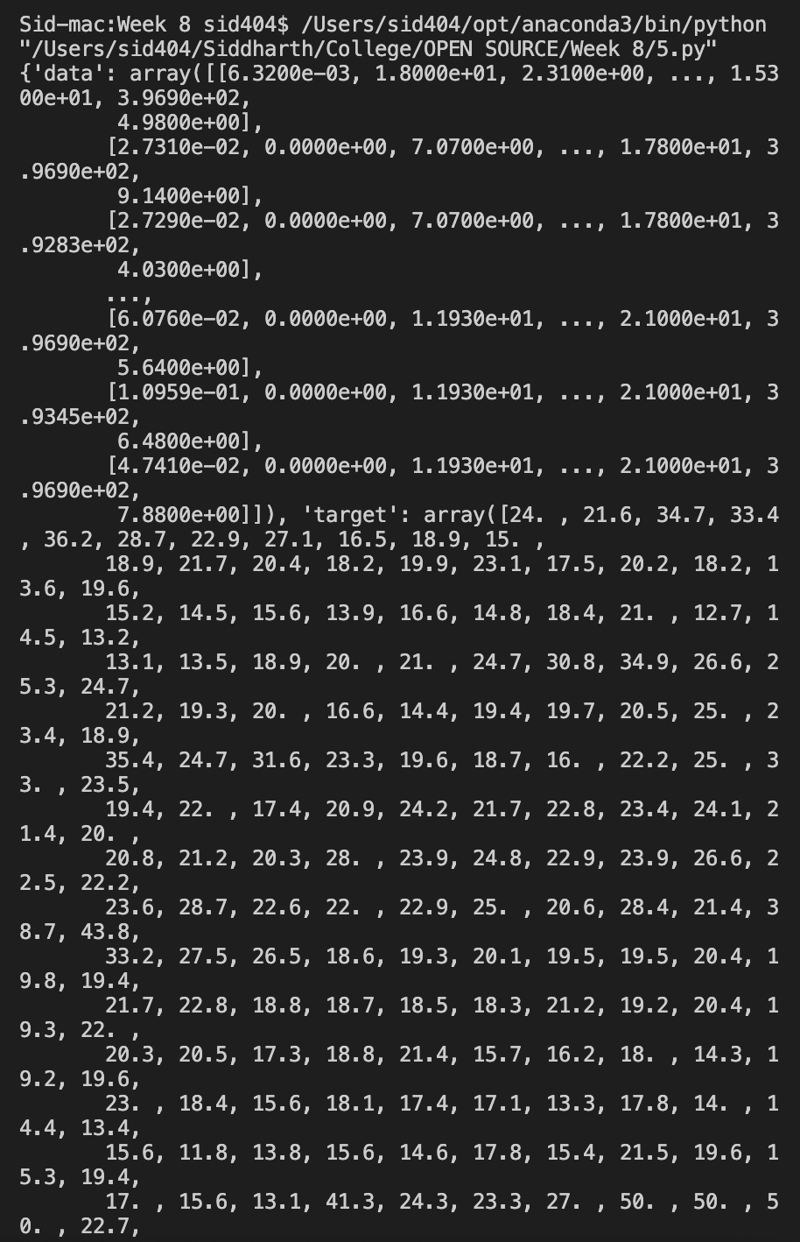

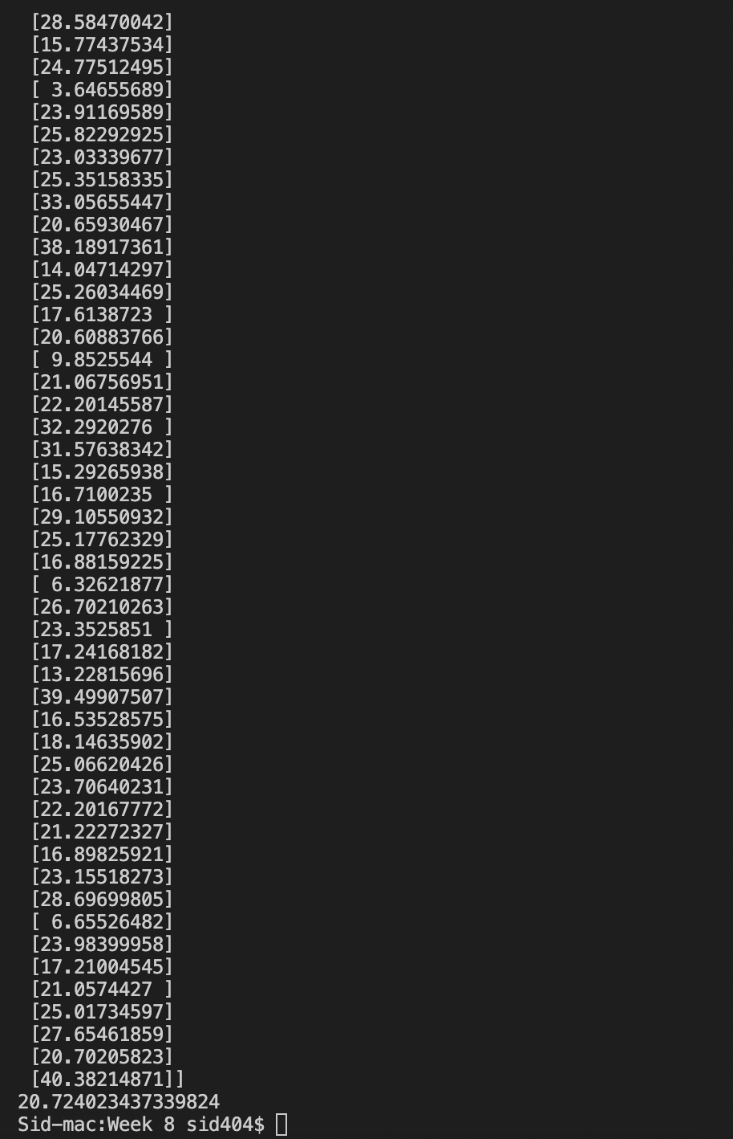

|  |
| --- |
| import pandas as pd  import numpy as np  from sklearn import linear_model  from sklearn.model_selection import train_test_split  from sklearn.datasets import load_boston  boston = load_boston()  print(boston)  df_x = pd.DataFrame(boston.data, columns = boston.feature_names)  df_y = pd.DataFrame(boston.target)  df_x.describe()  reg = linear_model.LinearRegression()  x_train, x_test, y_train, y_test = train_test_split(df_x, df_y, test_size=0.33, random_state=42)  reg.fit(x_train, y_train)  print(reg.coef_)  y_pred = reg.predict(x_test)  print(y_pred)  y_pred[2]  y_test[0]  from sklearn.metrics import mean_squared_error  print(mean_squared_error(y_test, y_pred)) |